Student’s name | …………………………………………………….…… | Grade | 4
Subject | Computer | Quiz No. | 1
Quiz No. ( 1 ) (Answer)

10
write the correct name of each part.

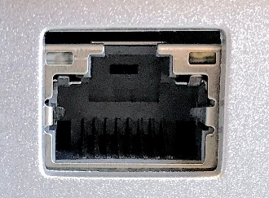

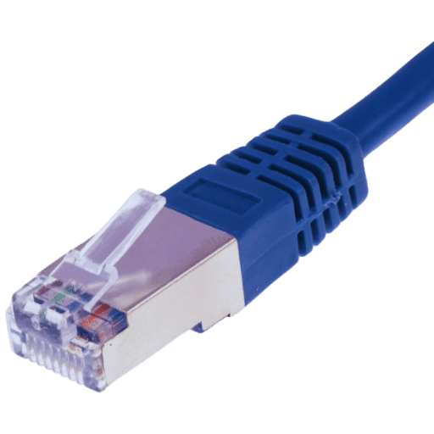
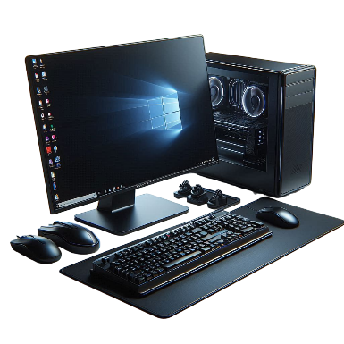
Ethernet Port
Laptop
Ethernet Cable
CPU
Good Luck

Ethernet Cable
Laptop
Ethernet Port
CPU
Vector

